Kent Mark

Cpre 489 – Lab 1

9/4/2021

Lab 1 Report

Exercise 1:

Ave. Round Trip time for [www.iastate.edu](http://www.iastate.edu): 0.783 ms

Ave. Round Trip time for [www.cam.ac.uk](http://www.cam.ac.uk): N/A

Ave. Round Trip time for [www.lenovo.com.cn](http://www.lenovo.com.cn): 30.8 ms

Exercise 2:

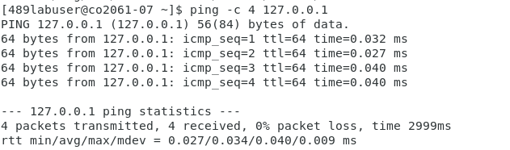The IP is a loopback address which means the machine is sending pings to itself, as such the latency is very low.

Exercise 3:

Facebook: 31.13.93.35 – star-mini.c10or.facebook.com

Microsoft: 23.35.205.40 – [www.microsoft.com-c-3.edgekey.net.globalredir.akadns.net](http://www.microsoft.com-c-3.edgekey.net.globalredir.akadns.net)

g.www.ms.akadns.net – N/A

Exercise 4:

10 vulcan.ece.iastate.edu

Exercise 5:

Spock.ee.iastate.edu

Spock.ee.iastate.edu

Exercise 6:

192.168.254.7 (Lab Computer 7)

Exercise 7:

The connection has to be around 1 Gbps since the bandwidth is showing 555 Mbps.

Exercise 8:

Number of hops: 22

Routes: The packets move through ISU’s network in 22 hops and are then routed through the web to reach CMU’s network. Once it’s in CMU’s network the routing tables find the correct path to [www.cmu.edu](http://www.cmu.edu)

Gateways: The gateways on this route go from ISU’s network, to the web, to CMU’s network

Latency: The round trip times for these packets were 41.654, 42.661, 44.221. So the average round time trip was 42.845.

Reachability: This host was very reachable because it did not block any of the ICMP packets that were being sent.

Exercise 9:

The tcptraceroute shows a lot more hop information. I think this because the gateways that are closer to the destination have a firewall that blocks the ICMP packets. The TCP SYN/ACK packets are able to break through more firewalls, allowing us to get more information.

Exercise 10:

Port 22 (SSH) is open.

Exercise 12:

The IP address of the attacking computer is 192.168.254.1

Exercise 13:

1. Source IP: 192.168.254.7 Destination IP: 82.221.107.34
2. Duration of connection: 20 seconds
3. Total amount of packets sent: 11

Exercise 14:

Data each ICMP packet contains: 98 bytes

Inter-arrival time: 207 (rough average)

Exercise 15:

Traceroute sends ICMP and UDP packets, TCPtraceroute sends TCP/SYN packets.